CERTIFICATE OF
Marriage

THIS CERTIFY THAT

Paul
& Anne

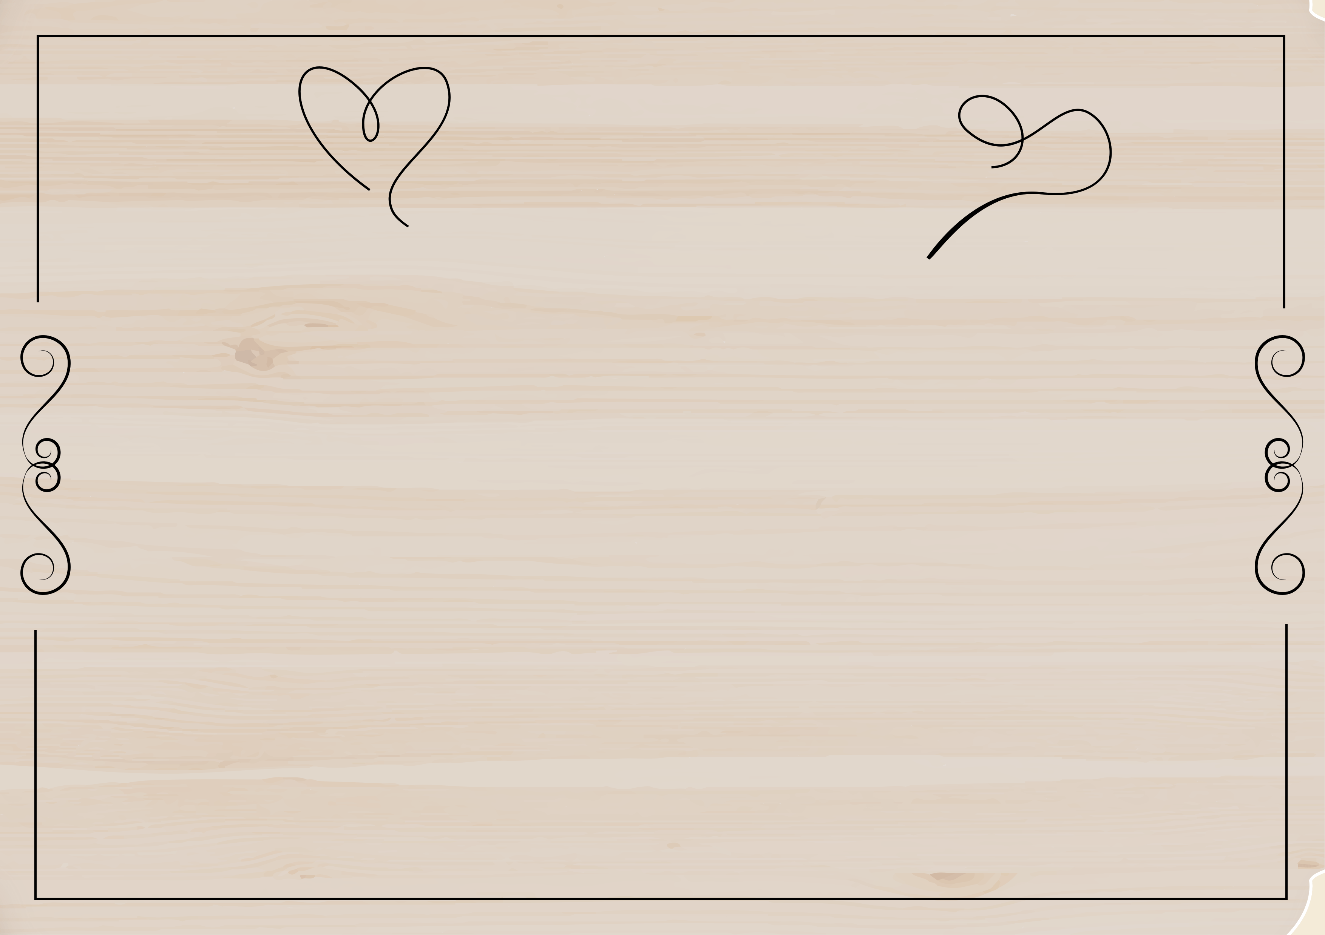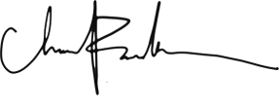Were Wed on the Day of In the year At

Groom

Bride

